**KLOV Server Setup**

Install MongoDb on the machine

**Download MongoDB Community Edition.**

Download the installer (.msi) from the [MongoDB Download Center](https://www.mongodb.com/download-center/community?jmp=docs):

1. The Download Center should display **MongoDB Community Server** download information. If not, select **Server**, then click the **MongoDB Community Server** tab.
2. In the **Version** dropdown, select the version that corresponds to the latest MongoDB Server 4.2.
3. In the **OS** dropdown, **Windows 64-bit X64** should be selected.
4. In the **Package** drop down, **MSI** should be selected.
5. Click **Download**.

**2**

**Run the MongoDB installer.**

For example, from the Windows Explorer/File Explorer:

1. Go to the directory where you downloaded the MongoDB installer (.msi file). By default, this is your Downloads directory.
2. Double-click the .msi file.

**3**

**Follow the MongoDB Community Edition installation wizard.**

The wizard steps you through the installation of MongoDB and MongoDB Compass.

1. **Choose Setup Type**

You can choose either the **Complete** (recommended for most users) or **Custom** setup type. The **Complete** setup option installs MongoDB and the MongoDB tools to the default location. The **Custom** setup option allows you to specify which executables are installed and where.

1. **Service Configuration**

Starting in MongoDB 4.0, you can set up MongoDB as a Windows service during the install or just install the binaries.

* + **MongoDB Service**
  + **MongoDB**

The following installs and configures MongoDB as a Windows service.

Starting in MongoDB 4.0, you can configure and start MongoDB as a Windows service during the install, and the MongoDB service is started upon successful installation.

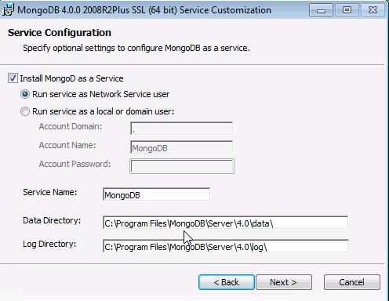

* + Select **Install MongoD as a Service** MongoDB as a service.
  + Select either:
    - **Run the service as Network Service user** (Default)

This is a Windows user account that is built-in to Windows

**or**

* + - **Run the service as a local or domain user**
      * For an existing local user account, specify a period (i.e. .) for the **Account Domain** and specify the **Account Name** and the **Account Password** for the user.
      * For an existing domain user, specify the **Account Domain**, the **Account Name** and the **Account Password** for that user.
  + **Service Name**. Specify the service name. Default name is MongoDB. If you already have a service with the specified name, you must choose another name.
  + **Data Directory**. Specify the data directory, which corresponds to the [--dbpath](https://docs.mongodb.com/manual/reference/program/mongod/#cmdoption-mongod-dbpath). If the directory does not exist, the installer will create the directory and sets the directory access to the service user.
  + **Log Directory**. Specify the Log directory, which corresponds to the [--logpath](https://docs.mongodb.com/manual/reference/program/mongod/#cmdoption-mongod-logpath). If the directory does not exist, the installer will create the directory and sets the directory access to the service user.

1. **Install MongoDB Compass**

For Windows 8 or greater, you can have the wizard install [MongoDB Compass](https://www.mongodb.com/products/compass). To install Compass, select **Install MongoDB Compass** (Default).

**NOTE**

The install script requires PowerShell version 3.0 or greater. If you have Windows 7, unclick the **Install MongoDB Compass**. You can manually [download Compass from the Download Center](https://www.mongodb.com/download-center/compass?jmp=docs).

1. When ready, click **Install**.

Download klov server

Download from GitHub:

<https://github.com/extent-framework/klov-server>

Run Klov:

java -jar klov-0.1.0.jar

**Admin**

Use the below super-user credentials:

* user: klovadmin
* pass: password

Execute Scripts via Klov:

Executing scripts using Klov server with the below example app.config settings

<!--Extent Report settings -->

    <add key="UseKlov" value="true" />

    <add key="MongodbUrl" value="10.47.9.42" />

    <add key="MongodbPort" value="27017" />

    <add key="KlovProjectName" value="Shell.TCOE.Automation Test Results" />

    <!--<add key="KlovUrl" value="<http://localhost:5689>" />-->

    <add key="KlovUrl" value="<http://10.47.9.42:85>" />

    <add key="KlovReportName" value="Shell.TCoE_SampleTestRun" />